MTN-036 Study Adherence Guidelines
Following all study instructions and requirements is important to ensure your safety as a participant and the validity of the study. Please review this document carefully and keep available for reference at home.
- Attend all Study Visits as Scheduled
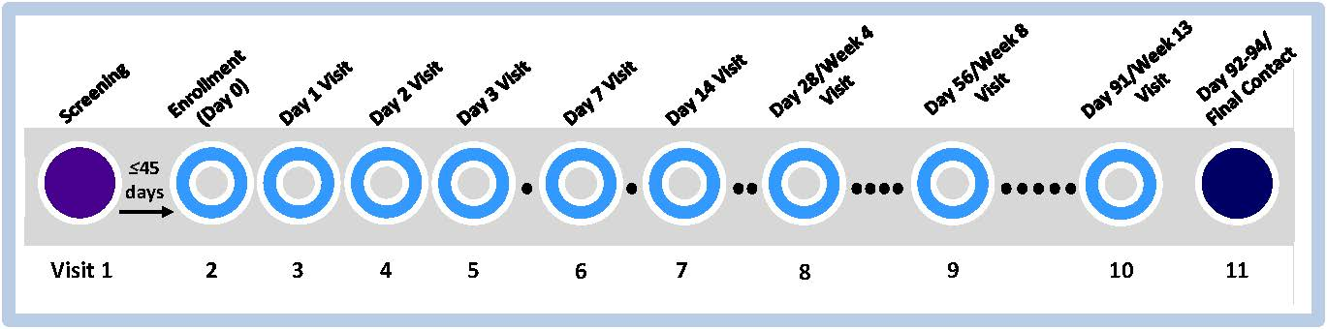
It is important for you to come to every study visit. If you cannot come to the visit, please tell the study staff as soon as possible so that the visit can be rescheduled.

- Use an effective contraceptive method
You must use an effective contraceptive method for the entire duration of the study. Effective methods include sterilization, hormonal methods (expect contraceptive rings), IUDs, and abstinence from penile-vaginal intercourse.

- Adhere to vaginal ring use instructions
Be aware of the instructions for inserting, wearing, and removing the vaginal ring provided by the study staff.

- Refrain from certain activities from during specified periods of time, as follows:
Duration of study participation beginning 24 hours before the enrollment visit
- Inserting any objects into your vagina, including:  - Sex toys  - Female condoms  - Diaphragms | - Menstrual cups  - Cervical caps or any other vaginal barrier method
- Using any vaginal products, including:  - Spermicides  - Lubricants  - Contraceptive VRs | - Douches  - Vaginal medications  - Vaginal moisturizers
- Taking specific medications*, such as
  - Anticoagulants or blood thinners (such as heparin, Lovenox®, warfarin, Plavix® [clopidogrel bisulfate)
  - Pre-exposure prophylaxis (PrEP) and post-exposure prophylaxis (PEP)
72 hours before each clinic visit | Additionally, 72 hours before and after each biopsy visit (Day 28, Day 91)
- Engaging in  - Receptive anal practices including:  - Penile-anal intercourse  - Receptive vaginal practices including:  - Penile-vaginal intercourse  - Receptive oral intercourse  - Finger stimulation (clitoral and vaginal) | - Taking Aspirin (greater than 81 mg)  - Vaginal Sexual Practices
24 hours before each clinic visit
Tampon use
*Let the clinic know if you start taking any medication so they can check to make sure the study products will not interfere with how your medication works.
If you have any questions or concerns about the study adherence guidelines, contact the following study staff:<Study Staff contact info>

