MTN-038 Study Adherence Guidelines
Following all study instructions and requirements is important to ensure your safety as a participant and the validity of the study. Please review this document carefully and keep available for reference at home.
- Attend all Study Visits as Scheduled
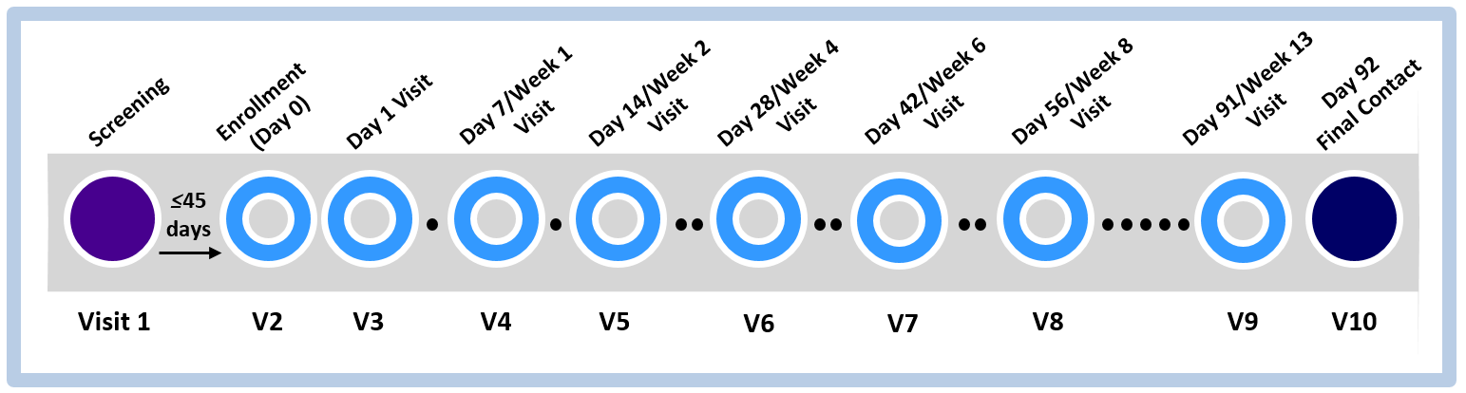
It is important for you to come to every study visit. If you cannot come to the visit, please tell the study staff as soon as possible so that the visit can be rescheduled.
- Use an effective contraceptive method
You must use an effective contraceptive method for the entire duration of the study. Effective methods include sterilization (yourself or your partner), hormonal methods (expect contraceptive rings), IUDs, and abstinence from penile-vaginal intercourse.
- Adhere to vaginal ring use instructions
Be aware of the instructions for inserting, wearing, and removing the vaginal ring provided by the study staff.
- Refrain from certain activities from during specified periods of time, as follows:
Duration of study participation
- Inserting any non-study vaginal products or objects into your vagina or rectum, including:
- Sex toys (dildos, vibrators, etc.)  - Note: External use is permitted.  - Female condoms  - Diaphragms  - Spermicides  - Lubricants | - Contraceptive vaginal rings  - Menstrual cups  - Cervical caps or any other vaginal barrier method  - Douches  - Vaginal or rectal medications  - Vaginal moisturizers
- Taking specific medications*, such as
  - Anticoagulants or blood thinners (such as heparin, Lovenox®, warfarin, Plavix® [clopidogrel bisulfate)
  - Pre-exposure prophylaxis (PrEP) and post-exposure prophylaxis (PEP)
72 hours before each clinic visit | Additionally, 72 hours before and after each biopsy collection visit
- Engaging in  - Receptive anal practices including:  - Penile-anal intercourse  - Receptive vaginal practices including:  - Penile-vaginal intercourse  - Receptive oral intercourse  - Finger stimulation (vaginal)  - Note: Clitoral stimulation is permitted. | - Taking Aspirin (greater than 81 mg)  - Receptive vaginal and anal sexual practices  (see column to left for specific examples)
24 hours before each clinic visit
- Tampon use
*Let the clinic know if you start taking any medication so they can check to make sure the study products will not interfere with how your medication works.
If you have any questions or concerns about the study adherence guidelines, contact the following study staff:<Study Staff contact info>

